CHAPTER 1

INTRODUCTION

1.1 MOTIVATION
In the pharmaceutical sector, managing inventory is crucial due to the short shelf life of products and strict regulatory requirements (e.g., Schedule H drugs, specific storage conditions). Manual or obsolete systems risk stock-outs, expiry of expensive drugs, inaccurate counts, and non-compliance. The primary motivation for this project is to develop an automated, efficient, and robust solution to track every unit of stock at the batch level, ensuring product integrity and enabling immediate recall and expiry checks.
1.2 EXISTING SYSTEM

The existing system is conceptualized as a legacy or manual record-keeping method (e.g., paper ledgers, spreadsheets). This system suffers from inherent drawbacks such as delayed data entry, high chances of human error in calculations, poor visibility into inventory levels across different locations, and reactive rather than proactive management of crucial parameters like reorder levels and impending expiry dates.
1.3 PROJECT OBJECTIVES

The main objectives of the Pharmaceutical IMS project are:

- To establish a well-structured Relational Database Schema in MySQL capable of managing all pharmaceutical logistics data.
- To accurately maintain Master Records for all Drugs, Suppliers, Locations, and Users.
- To implement transactional modules for Purchase Order (PO) creation and maintenance of Goods Received Notes (GRN).
- To ensure batch-level tracking and capture essential product data like batch_number and expiry_date at the point of receipt (GRN).
- To maintain a Stock Inventory that accurately reflects the quantity of each specific batch at a designated physical location.
- To provide an intuitive, role-based user interface for managing operations (Inferred from role field in User_Master and presence of GUI classes).

1.4 PROPOSED SYSTEM

The Proposed System is a Pharmaceutical Inventory Management System built on a client-server architecture. It utilizes a Java front-end application (GUI) and a MySQL database backend. The system centralizes all inventory data, applying business rules at the database level (e.g., FOREIGN KEY constraints) and the application level (e.g., stock update logic within Java services). It provides role-based access for different user types like 'Admin', 'Pharmacist', and 'Staff'. The core process flow links the procurement cycle (PO) to the receiving cycle (GRN), which finally updates the physical inventory (Stock_Inventory).

CHAPTER 2

LITERATURE REVIEW

2.1 OVERVIEW

Inventory management is a crucial function in logistics and supply chain systems. Literature consistently emphasizes the shift from manual to computerized systems for improved efficiency, cost reduction, and enhanced decision-making capabilities. Modern DBMS solutions are preferred for their ability to enforce data integrity, manage concurrent user access, and handle complex relational data models.

2.2 PHARMACEUTICAL INVENTORY MANAGEMENT SYSTEM

Inventory control in the pharmaceutical industry is distinctly more critical than in general retail due to:
- Strict Expiry Dates: The system must track inventory at the batch level (batch_number, expiry_date in GRN_Item and Stock_Inventory) to minimize financial loss from expired goods and ensure patient safety.
- Regulatory Compliance: The system must track drug categories (like 'Schedule H') and specific storage conditions (Drug_Master table) to adhere to pharmaceutical laws.
- Traceability: Complete audit trails are required, linking received stock (GRN) back to the original Purchase Order (PO) and the Supplier for easy recall management.
2.3 FEATURES AND FUNCTIONALITIES

Based on the implemented structure, the core functionalities reviewed and utilized are:
- Master Data Maintenance: Centralized records for Suppliers (Supplier_Master), Drugs (Drug_Master), and Storage Locations (Location_Master).
- Procurement Cycle: Structured data flow from Purchase_Order creation to Goods_Received_Note generation.
- Batch Tracking: The use of the GRN_Item and Stock_Inventory tables ensures that physical inventory reflects stock accurately by material_code, location_code, and unique batch_number.
- Control Mechanisms: Setting of reorder_level on the Drug_Master enables automated stock monitoring and alerts.
2.4 RELEVANCE TO PROJECT
The existing literature confirms that a robust relational database model is the standard for complex inventory needs, especially when multi-level tracking (drug -> batch -> location) is required. The current project directly implements these best practices by employing an RDBMS schema (MySQL) to model master and transactional entities, enforcing referential integrity and ensuring the storage of critical batch metadata essential for pharmaceutical operations.

CHAPTER 3

SYSTEM DESIGN

3.1 SYSTEM OVERVIEW
The Pharmaceutical IMS operates on a two-tier architecture. The system is composed of the Client (Presentation Layer and some Business Logic) and the Database Server (Data Layer). The system is centralized, meaning all clients connect to a single database instance via JDBC for all data operations, while the logic is handled by Java classes in the Application layer.
3.2 SYSTEM ARCHITECTURE

3.2.1 SYSTEM ARCHITECTURE OVERVIEW

The architecture is layered as follows:
- Data Layer (Backend): Consists of the MySQL Database (pharma_ims) and the JDBC connector library. This layer handles data storage, retrieval, and persistence, governed by the schema defined in db_setup.sql.
- Business/Logic Layer: Implemented in Java classes (e.g., DatabaseService.java, AuthService.java). This layer contains the core application logic, such as validating user input, performing multi-step operations (e.g., creating a GRN and updating stock), and enforcing security rules.
- Presentation Layer (Client): Consists of the Java GUI components (e.g., LoginGUI.java, DashboardPanel.java, PurchaseOrderPanel.java). This layer provides the user interface for interaction and displays the processed data fetched from the database.

3.2.2 USE CASE DIAGRAM OVERVIEW

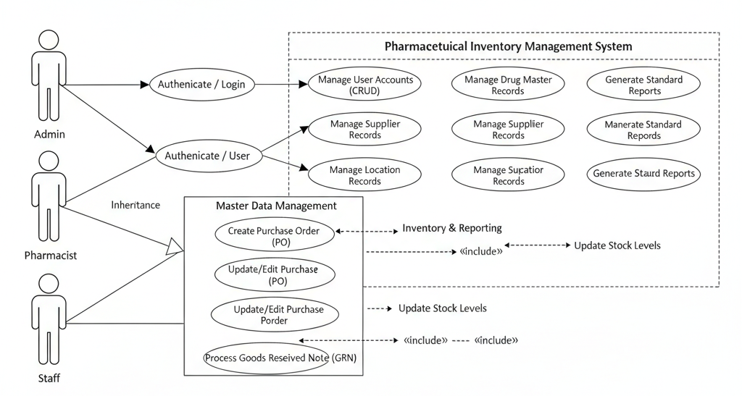

The main actors in the system are Admin, Pharmacist, and Staff. The core processes revolve around: User Authentication; Master Data Management (for Drugs, Suppliers, Locations); Procurement Workflow (PO and GRN creation); and Inventory Query/Reporting.
3.2.3 KEY USE CASES

- User Authentication: Any user (Admin, Pharmacist, Staff) attempts to log in using credentials verified against the User_Master table.
- Drug/Master Data Management (Admin/Pharmacist): Create, Retrieve, Update, or Delete (CRUD) records in Drug_Master, Supplier_Master, and Location_Master.
- New Purchase Order (Staff/Pharmacist): Create an entry in Purchase_Order and associated records in PurchaseOrder_Item, linking to a specific Supplier_Master.
- Goods Receipt (Staff/Pharmacist): Create a Goods_Received_Note linked to a Purchase_Order, capturing detailed batch information in GRN_Item, and subsequently updating the Stock_Inventory table.
- Inventory Check (All Users): View real-time stock levels, batches, expiry dates, and locations from the Stock_Inventory table.
3.2.4 RELATIONSHIPS
The database employs a highly normalized relational structure with explicit foreign keys:
- One-to-Many Relationships:
  - Supplier_Master (1) Drug_Master (N) (Preferred Supplier).
  - Supplier_Master (1) Purchase_Order (N).
  - Purchase_Order (1) PurchaseOrder_Item (N) GRN_Item (N) Goods_Received_Note (N).
- Composite Key/Junction-like Relationship (Many-to-Many resolution):
  - The Stock_Inventory table resolves the N:M relationship between Drug_Master and Location_Master (i.e., many drugs can be in many locations, and one location can hold many drugs) by using a composite unique key: (material_code, location_code, batch_number).

3.3. SYSTEM REQUIREMENTS
The Pharmaceutical Inventory Management System (pharma-ims) operates on a client-server architecture, requiring specific hardware and software components to function effectively.
1. Backend & Application Server
- Operating System: Windows Server, Linux, or macOS.
- Database Management System: MySQL (or a compatible MariaDB/Percona Server) for managing all master and transactional data (Drugs, Suppliers, Purchase Orders, GRNs, and Stock Inventory). The database name is explicitly pharma_ims.
- Programming Language: Java for the entire backend application logic (Business and Data Access layers).
- Database Connectivity: JDBC (Java Database Connectivity) for establishing a seamless connection between the Java application and the MySQL database.
- Application Hosting/Runtime: A Java Runtime Environment (JRE) version 8 or later is required to run the Java-based application/backend services.
2. Frontend (Client Application)
- Client Type: Desktop Application. The front-end user interface is implemented as a standalone executable client, not a web application, based on the presence of GUI-specific Java classes (...GUI.java, ...Panel.java, ...Dialog.java).
- GUI Libraries: Java Swing/AWT (Standard Java GUI libraries) are used to render the interface panels and dialogs (e.g., LoginGUI, InventoryGUI, CreatePurchaseOrderDialog).
- Client Runtime: A Java Runtime Environment (JRE) must be installed on the client machine to launch and operate the GUI application.
3. Development Tools
- IDE: An integrated Development Environment (IDE) that supports Java and SQL development, such as IntelliJ IDEA, Eclipse, or Visual Studio Code (with Java extensions).
- Version Control System: Git for source code control and collaborative development.
- Database Tool: A utility like MySQL Workbench or DBeaver for initial database creation, schema setup, and data insertion/testing (e.g., executing the db_setup.sql script).

3.4. DATABASE DESIGN

The database consists of two primary tables:

1. User_Master table is used to store user credentials for logging into the system.
2. Supplier_Master: This table stores comprehensive master data for all pharmaceutical suppliers/distributors.
3. Drug_Master: This master table maintains the core catalog of all individual drug products stocked.
4. Location_Master: This table defines all possible physical locations within the facility where stock can be stored.
5. Purchase_Order: This table serves as the header record for every commitment to purchase drugs from a supplier.
6. Goods_Received_Note: This table documents the administrative confirmation that an order (or part of an order) has been physically received.
7. Stock_Inventory: This is the core table representing the current, physical, on-hand stock.
Table: User_Master

Purpose:

The User_Master table is used to store user credentials for logging into the system. It includes each user's unique ID, their hashed password, and their role (e.g., 'Admin', 'Pharmacist', 'Staff') for granting appropriate access permissions.
Table Schema:

Table 3.1. User_Master Schema

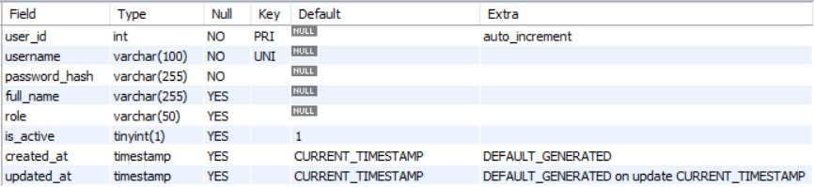

Constraints:
- Primary Key: The user_id column is defined as the Primary Key to ensure uniqueness across the user records.
- Unique Key: The username column is defined as UNIQUE, enforcing that no two users can share the same login name.
- NOT NULL: The username and password_hash columns are defined with the NOT NULL constraint.

SQLDefinition:

CREATE TABLE IF NOT EXISTS User_Master (
user_id INT AUTO_INCREMENT PRIMARY KEY,
username VARCHAR(100) UNIQUE NOT NULL,
password_hash VARCHAR(255) NOT NULL,
full_name VARCHAR(255),
role VARCHAR(50),
is_active BOOLEAN DEFAULT TRUE,
created_at TIMESTAMP DEFAULT CURRENT_TIMESTAMP,
updated_at TIMESTAMP DEFAULT CURRENT_TIMESTAMP ON UPDATE CURRENT_TIMESTAMP
);
Table: Supplier_Master

Purpose:

This table stores comprehensive master data for all pharmaceutical suppliers/distributors. It is crucial for procurement and includes contact details, payment terms, and regulatory identifiers like the gstin and drug_license_number.

Table Schema:

Table 3.2. Supplier_Master Schema

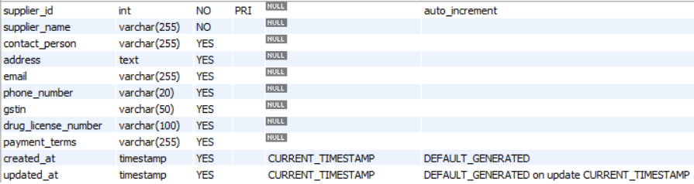

Constraints:
- Primary Key: The supplier_id column is defined as the Primary Key.
- NOT NULL: The supplier_name column cannot be empty.

SQLDefinition:
CREATE TABLE IF NOT EXISTS Supplier_Master (
supplier_id INT AUTO_INCREMENT PRIMARY KEY,
supplier_name VARCHAR(255) NOT NULL,
contact_person VARCHAR(255),
address TEXT,
email VARCHAR(255),
phone_number VARCHAR(20),
gstin VARCHAR(50),
drug_license_number VARCHAR(100),
payment_terms VARCHAR(255),
created_at TIMESTAMP DEFAULT CURRENT_TIMESTAMP,
updated_at TIMESTAMP DEFAULT CURRENT_TIMESTAMP ON UPDATE CURRENT_TIMESTAMP);

Table : Drug_Master

Purpose:
This master table maintains the core catalog of all individual drug products stocked. It captures critical fields like brand_name, generic_name, strength, required storage_conditions, and the minimum reorder_level for inventory management.

Table Schema:
Table 3.2. Drug_Master Schema

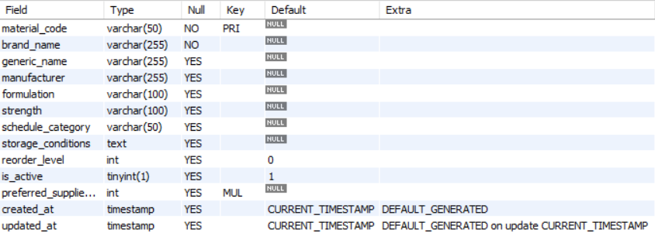

Constraints:
- Primary Key: The material_code serves as the unique identifier for each drug product.
- Foreign Key: The optional preferred_supplier_id links to the Supplier_Master table. It uses ON DELETE SET NULL to ensure the drug record is kept if the supplier is deleted.
- NOT NULL: The brand_name is mandatory.

SQL Definition:

CREATE TABLE IF NOT EXISTS Drug_Master (
material_code VARCHAR(50) PRIMARY KEY,
brand_name VARCHAR(255) NOT NULL,
generic_name VARCHAR(255),
manufacturer VARCHAR(255),
formulation VARCHAR(100),
strength VARCHAR(100),
schedule_category VARCHAR(50),
storage_conditions TEXT,
reorder_level INT DEFAULT 0,
is_active BOOLEAN DEFAULT TRUE,

preferred_supplier_id INT,

created_at TIMESTAMP DEFAULT CURRENT_TIMESTAMP,
updated_at TIMESTAMP DEFAULT CURRENT_TIMESTAMP ON UPDATE CURRENT_TIMESTAMP,

-- Define the Foreign Key constraint for preferred supplier
FOREIGN KEY (preferred_supplier_id) REFERENCES Supplier_Master(supplier_id)
ON DELETE SET NULL
ON UPDATE CASCADE
);

Table : Location_Master

Purpose:
This table defines all possible physical locations within the facility where stock can be stored. This allows for accurate tracking of where every drug batch is physically located, aiding retrieval and inventory audits.

Table Schema:
Table 3.2. Location_Master Schema

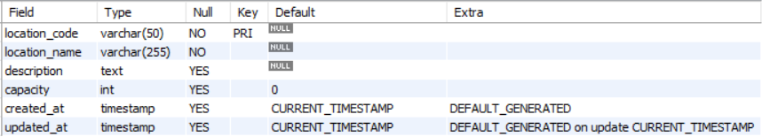

Constraints:
• Primary Key: The location_code acts as the unique identifier for each storage area.
• NOT NULL: The location_name is mandatory.

SQLDefinition:
CREATE TABLE IF NOT EXISTS Location_Master (
location_code VARCHAR(50) PRIMARY KEY,
location_name VARCHAR(255) NOT NULL,
description TEXT,
capacity INT DEFAULT 0,
created_at TIMESTAMP DEFAULT CURRENT_TIMESTAMP,
updated_at TIMESTAMP DEFAULT CURRENT_TIMESTAMP ON UPDATE CURRENT_TIMESTAMP
);

Table : Purchase_Order

Purpose:
This table serves as the header record for every commitment to purchase drugs from a supplier. It captures order-level information, such as the order_date, expected delivery date, and the overall status ('Pending', 'Received').

Table Schema:

Table 3.2. Purchase_Order Schema

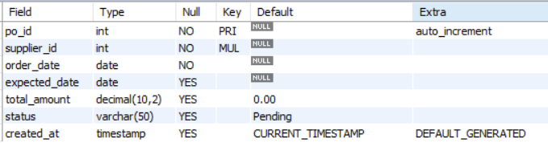

Constraints:
- Primary Key: The po_id is the unique identifier for the purchase order.
- Foreign Key: The supplier_id links to Supplier_Master(supplier_id). Action: ON DELETE RESTRICT prevents deletion of a supplier if open orders still exist.
- NOT NULL: The supplier_id and order_date fields are mandatory.

SQLDefinition:
CREATE TABLE IF NOT EXISTS Purchase_Order (
po_id INT AUTO_INCREMENT PRIMARY KEY,
supplier_id INT NOT NULL,
order_date DATE NOT NULL,
expected_date DATE,
total_amount DECIMAL(10, 2) DEFAULT 0.00,
status VARCHAR(50) DEFAULT 'Pending', -- Pending, Shipped, Received
created_at TIMESTAMP DEFAULT CURRENT_TIMESTAMP,
FOREIGN KEY (supplier_id) REFERENCES Supplier_Master(supplier_id)
ON DELETE RESTRICT
ON UPDATE CASCADE
);

Table: Goods_Received_Note

Purpose:

This table documents the administrative confirmation that an order (or part of an order) has been physically received. It links the receipt directly to the original Purchase_Order and records who received the goods and when.
Table Schema:

Table 3.1. Goods_Received_Note Schema

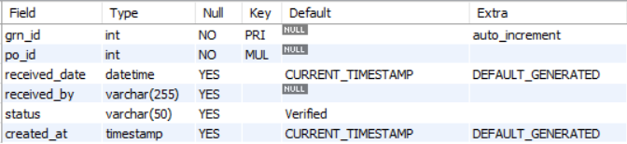

Constraints:
- Primary Key: The grn_id is the unique identifier for the goods receipt transaction.
- Foreign Key: The po_id links to Purchase_Order(po_id). Action: ON DELETE RESTRICT prevents the deletion of a PO if goods have already been received against it.
- NOT NULL: The po_id field is mandatory.
SQLDefinition:

CREATE TABLE IF NOT EXISTS Goods_Received_Note (
grn_id INT AUTO_INCREMENT PRIMARY KEY,
po_id INT NOT NULL,
received_date DATETIME DEFAULT CURRENT_TIMESTAMP,
received_by VARCHAR(255),
status VARCHAR(50) DEFAULT 'Verified',
created_at TIMESTAMP DEFAULT CURRENT_TIMESTAMP,

FOREIGN KEY (po_id) REFERENCES Purchase_Order(po_id)
ON DELETE RESTRICT
ON UPDATE CASCADE
);

Table: Stock_Inventory

Purpose:

This is the core table representing the current, physical, on-hand stock. Each record tracks the quantity of a specific material_code (drug), identified by a unique batch_number, located at a specific location_code. This granularity is vital for managing expiry dates and product recalls.
Table Schema:

Table 3.1. Stock_Inventory Schema

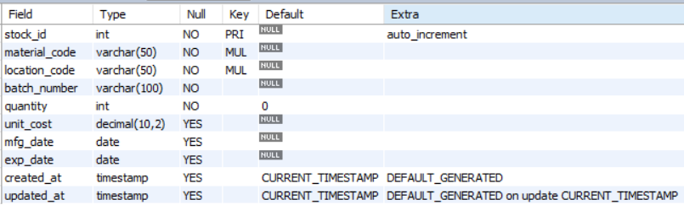

Constraints:
- Primary Key: stock_id is the row identifier.
- Unique Key: The composite key (material_code, location_code, batch_number) ensures that a specific production batch of a drug is tracked only once per physical location, preventing redundant records and maintaining data integrity.
- Foreign Key: material_code links to Drug_Master(material_code). Action: ON DELETE RESTRICT prevents deletion of a drug record if stock exists.
- Foreign Key: location_code links to Location_Master(location_code). Action: ON DELETE RESTRICT prevents deletion of a location while it holds stock.
- NOT NULL: material_code, location_code, batch_number, and quantity are mandatory fields.

SQLDefinition:

CREATE TABLE IF NOT EXISTS Stock_Inventory (
stock_id INT AUTO_INCREMENT PRIMARY KEY,
material_code VARCHAR(50) NOT NULL,
location_code VARCHAR(50) NOT NULL,
batch_number VARCHAR(100) NOT NULL,
quantity INT NOT NULL DEFAULT 0,
unit_cost DECIMAL(10, 2),
mfg_date DATE,
exp_date DATE,

-- Ensures a specific batch of a drug is tracked only once per location
UNIQUE KEY (material_code, location_code, batch_number),

FOREIGN KEY (material_code) REFERENCES Drug_Master(material_code)
ON DELETE RESTRICT
ON UPDATE CASCADE,
FOREIGN KEY (location_code) REFERENCES Location_Master(location_code)
ON DELETE RESTRICT
ON UPDATE CASCADE,

created_at TIMESTAMP DEFAULT CURRENT_TIMESTAMP,
updated_at TIMESTAMP DEFAULT CURRENT_TIMESTAMP ON UPDATE CURRENT_TIMESTAMP
);

CHAPTER 4

PROJECT DESCRIPTION

The Pharmaceutical Inventory Management System (pharma-ims) is a database-backed application designed to manage the entire lifecycle of pharmaceutical products, with a core focus on granular, batch-level inventory control. The system is built around three main functional modules: Master Data Management, Procurement Workflow, and Inventory Control.
4.1 Master Data Management
This module handles the static, reference data essential for daily operations.
- Drug Master (Drug_Master): This is the core catalog, identifying each drug by a unique material_code. It tracks critical information necessary for compliance and purchasing, including the brand_name, generic_name, manufacturer, strength, and regulatory data like the schedule_category ('Schedule H', 'OTC'). It also stores specific storage_conditions and defines a reorder_level for replenishment planning. It maintains a link to a preferred_supplier_id.
- Supplier Master (Supplier_Master): Stores comprehensive details for all drug vendors, including supplier_name, contact information, and mandatory compliance identifiers like gstin and drug_license_number.
- Location Master (Location_Master): Defines and tracks all physical storage areas (e.g., "Cold Storage B2," "Warehouse Zone A1") using a unique location_code and storing its storage capacity.
- User Master (User_Master): Manages user access, utilizing a username, password_hash, and assigning a hierarchical role ('Admin', 'Pharmacist', 'Staff') for permission control.
4.2 Procurement Workflow (PO & GRN)
This module automates the process from ordering stock to receiving it into the warehouse.
- Purchase Order (PO):
  - The purchase process begins with the Purchase_Order header, recording basic order details like supplier_id, order_date, expected_date, and overall status ('Pending', 'Shipped', 'Received').
  - Details of the requested drugs are stored in the PurchaseOrder_Item table, linking back to the PO header via po_id and specifying the drug_id, quantity, and unit_price.
- Goods Received Note (GRN):
  - The Goods_Received_Note documents the physical receipt of goods against a PO. It links to the relevant po_id and records the received_date and the received_by user.
  - The crucial component is the GRN_Item table, which captures lot-specific information for the inventory, recording the unique batch_number and the expiry_date of the received drugs.
4.3 Inventory Control
This module holds the definitive truth regarding on-hand stock and physical placement.
- Stock Inventory (Stock_Inventory): This is the central transactional table for current inventory levels.
- Key Tracking Dimensions: To ensure precision, stock is tracked at the most granular level, enforced by a unique key defined by the combination of material_code, location_code, and batch_number.
- Inventory Update: The stock quantity is updated in this table based on the successful processing of a GRN_Item record. It permanently stores financial (like unit_cost) and quality control data (like mfg_date and exp_date).
This design prioritizes lot/batch traceability and expiry date visibility, which are non-negotiable requirements for a compliant pharmaceutical inventory system.

CHAPTER 5

OUTPUT SCREEN SHOTS

LOGIN/SIGN UPPAGE:

Serves as the entry point for users, allowing them to either log in with existing credentials or

navigate to the sign-up page to create a new account.

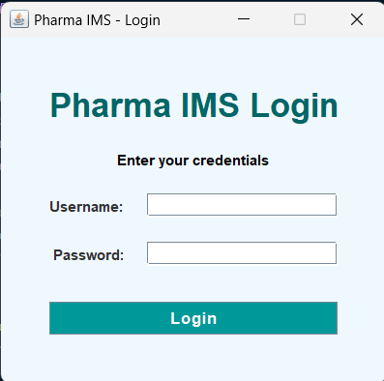

Figure 5.1. Login/Sign Up

LOGIN PAGE:

Users enter their username and password to access the system. Invalid attempts prompt

error messages for correction.
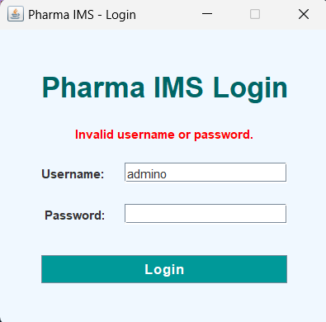
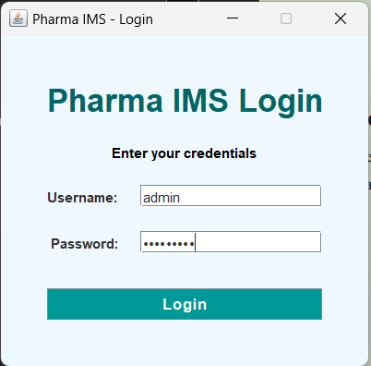

Figure 5.2. Login Figure

DRUG MASTER:

Displays the drugs details such as drug id, brand name, generic name, manufacturer, formulation, strength, reorder level and preferred supplier id, etc.

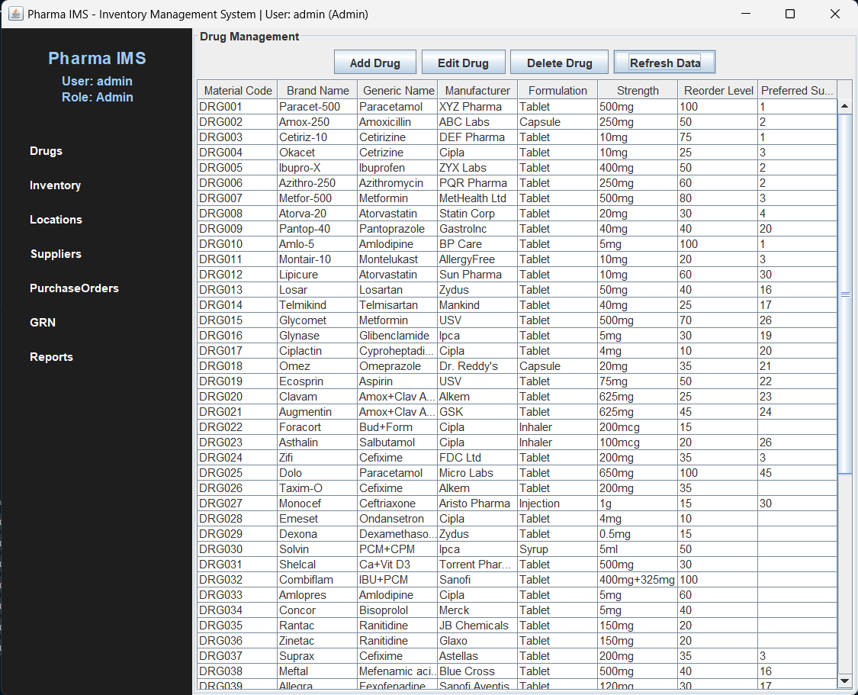

Figure 5.3. Drug Panel on display

CRUD OPERATION IN DRUG MASTER:

Performs Create, Update, Delete operations on Drug_Master table.

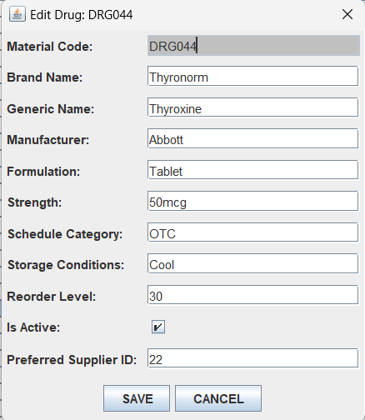
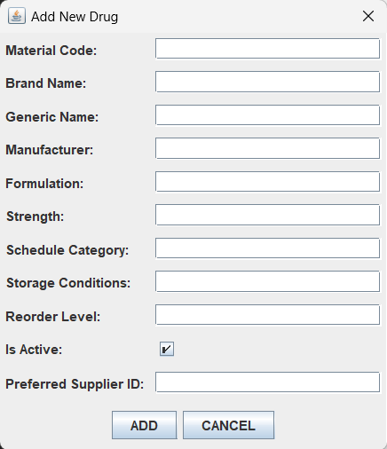

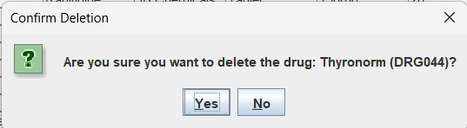

Figure 5.4. CRUD operations on Drug_Master table

INVENTORY PANEL:

Displays the drug id, brand name, generic name, manufacturer and reorder level.
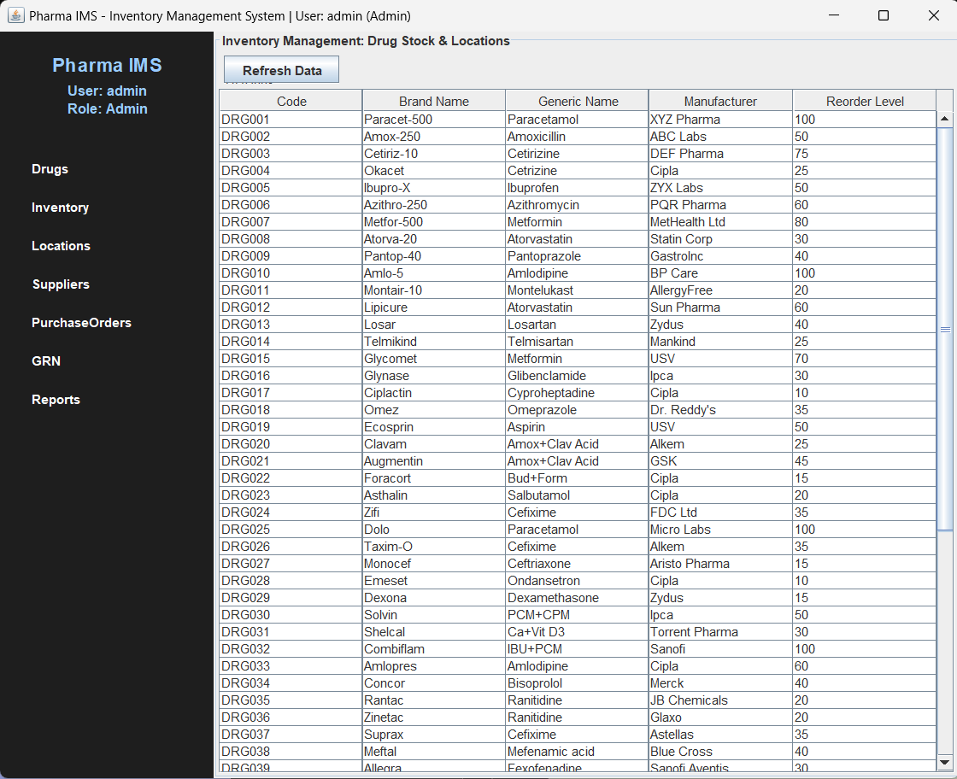

Figure 5.5. Inventory Panel Display

LOCATION PANEL:

Displays the Location_master table, this panel displays location code, location name, description and capacity.

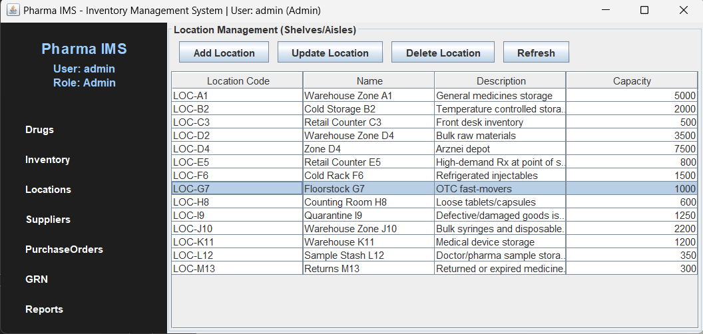

Figure 5.6. Location Panel Display

CRUD OPERATION IN LOCATION MANAGEMENT:

Performs Create, Update, Delete operations on Location_Master table.

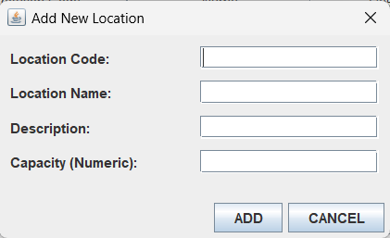
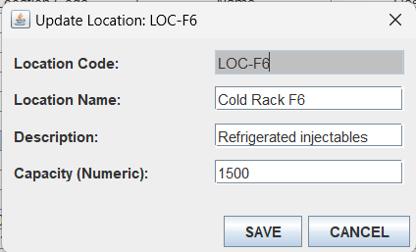

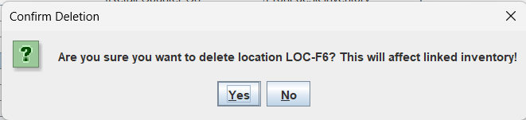

Figure 5.7. CRUD operations on Location_Master table

SUPPLIER MASTER:
Displays all the records from the Supplier_Master, supplier id, supplier name, contact person, email, phone, GSTIN, liscense id and payment terms.

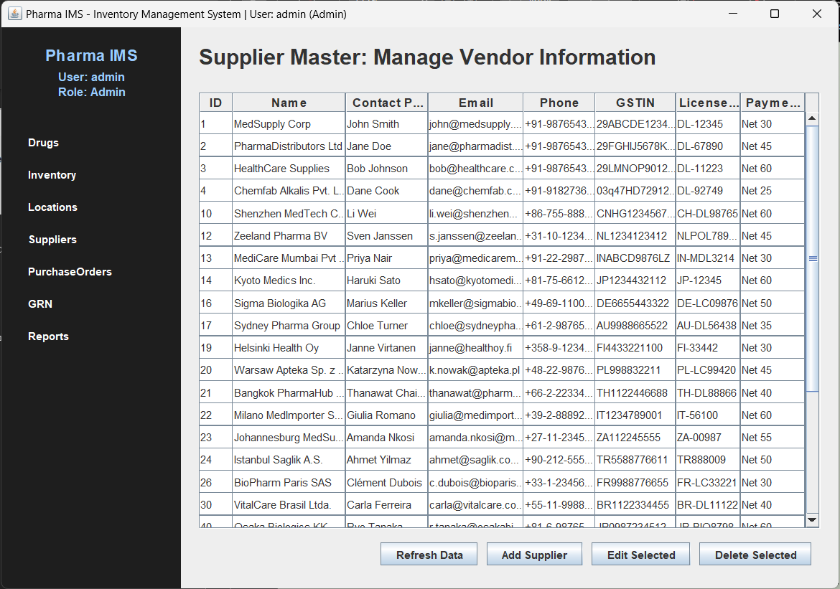

Figure 5.8. CRUD operations on Location_Master table

CRUD OPERATION IN SUPPLIER MASTER:

Performs Create, Update, Delete operations on Supplier_Master table.
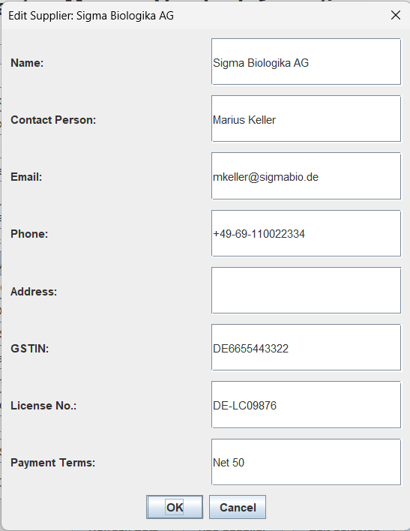
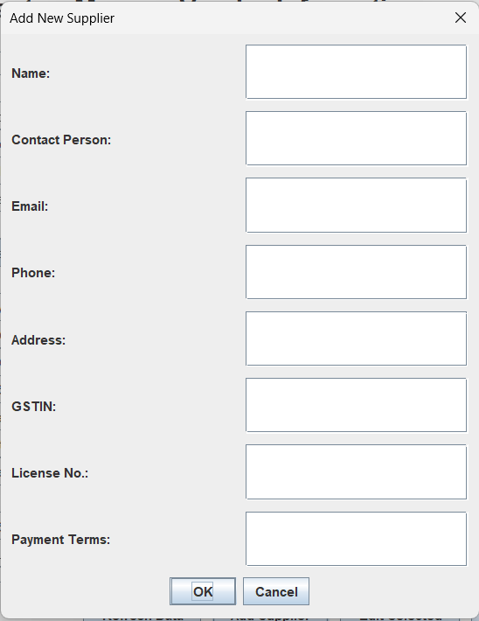

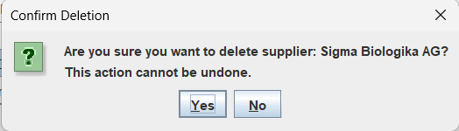

Figure 5.9. CRUD Operations on Supplier Master

PURCHASE ORDER:

Displays the purchase order details, namely, purchase order id, supplier name, order date, expected date, total cost and status.
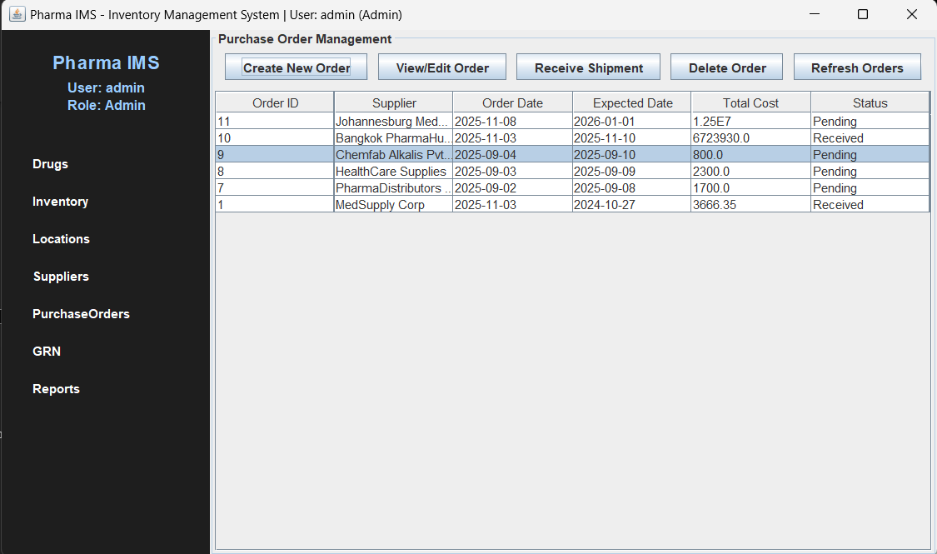

Figure 5.10. Purchase Order panel displaying purchase order details.

CRUD OPERATIONS ON PURCHASE ORDER:

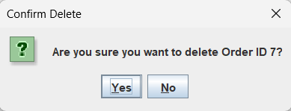
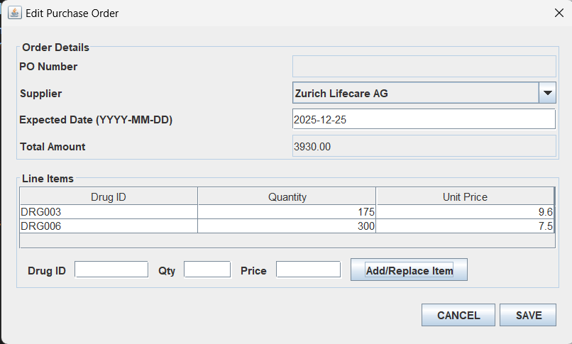
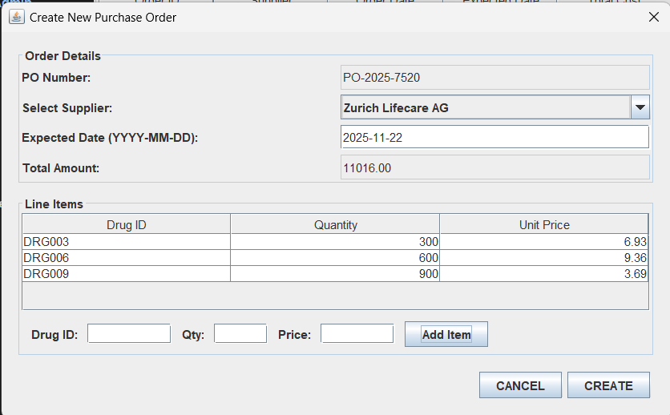

Figure 5.11. Performing CRUD operations on Purchase Order

CHAPTER 6

CONCLUSIONAND FUTURE WORKS

The Pharmaceutical Inventory Management System successfully fulfils the objectives of providing a reliable, computerized, and batch-aware inventory solution. Leveraging MySQL's relational capabilities and Java's application framework, the project offers a structured way to manage critical pharmaceutical data, streamline procurement (PO/GRN), and enable granular stock control, thereby mitigating risks associated with drug expiry and manual errors. The design is modular and extensible, setting a solid foundation for future enhancements.
Potential future enhancements to the system include:
- Automated Alerts and Notifications: Implement logic (e.g., scheduled tasks or triggers) to automatically generate alerts when the stock quantity falls below the specified reorder_level for a drug or when a batch's exp_date is nearing.
- Reporting Module Enhancement: Develop advanced analytical reports (as noted in ReportsPanel.java) for drug consumption rate, supplier performance, and financial valuation of inventory.
- Advanced User Management: Implement stronger security by replacing plaintext passwords with industry-standard hashing and salting techniques for the password_hash field in User_Master.
- Sales/Outward Transaction Module: Develop a module to track drug dispensing or sales to accurately manage outgoing inventory and maintain a complete audit trail.

REFERENCES

[1] Smith, J. R., & Johnson, A. M. (Year). Optimizing Pharmaceutical Inventory Management through Database Systems. Journal of Healthcare Logistics https://www.researchgate.net/publication/384987682_Optimizing_pharmaceutical_inventory_management_A_global_framework_for_efficiency_and_cost_reduction

[2] World Health Organization (WHO). (2020). Good Storage and Distribution Practices for Medical Products.
https://www.who.int/publications/i/item/978-92-4-000182-4

[3] Vodnala Supriya1, Dr. G. Krishna Kumari, Design and Implementation of an Inventory Management System (IMS)
https://ijrpr.com/uploads/V6ISSUE8/IJRPR52286.pdf

[4] Silberschatz, A., Korth, H. F., & Sudarshan, S. S. (2020). Database System Concepts, 7th Edition, McGraw-Hill.

[5] Herbert Schildt and Dr. Danny Coward. Java: The Complete Reference, Thirteenth Edition

[6] MySQL Official Documentation. MySQL 8.0 Reference Manual.

[7] Oracle (Java) Official Documentation. JDBC™ API Tutorial and Reference.
https://docs.oracle.com/javase/tutorial/jdbc/

APPENDIX

DATABASE SCHEMA DEFINITION

-- 1. Create Database and Switch Context
CREATE DATABASE IF NOT EXISTS pharma_ims;
USE pharma_ims;

-- 2. Drop existing tables for a clean slate (Run this script multiple times)
DROP TABLE IF EXISTS GRN_Item;
DROP TABLE IF EXISTS Goods_Received_Note;
DROP TABLE IF EXISTS PurchaseOrder_Item;
DROP TABLE IF EXISTS Purchase_Order;
DROP TABLE IF EXISTS Stock_Inventory;
DROP TABLE IF EXISTS Drug_Master;
DROP TABLE IF EXISTS Supplier_Master;
DROP TABLE IF EXISTS Location_Master;
DROP TABLE IF EXISTS User_Master;

-- ---------------------------------------------------------------------
-- MASTER TABLES (Primary Data)
-- ---------------------------------------------------------------------

-- 3. Supplier Master Table
CREATE TABLE IF NOT EXISTS Supplier_Master (
supplier_id INT AUTO_INCREMENT PRIMARY KEY,
supplier_name VARCHAR(255) NOT NULL,
contact_person VARCHAR(255),
address TEXT,
email VARCHAR(255),
phone_number VARCHAR(20),
gstin VARCHAR(50),
drug_license_number VARCHAR(100),
payment_terms VARCHAR(255),
created_at TIMESTAMP DEFAULT CURRENT_TIMESTAMP,
updated_at TIMESTAMP DEFAULT CURRENT_TIMESTAMP ON UPDATE CURRENT_TIMESTAMP
);

-- 4. Drug Master Table (Includes Foreign Key to Supplier)
CREATE TABLE IF NOT EXISTS Drug_Master (
material_code VARCHAR(50) PRIMARY KEY,
brand_name VARCHAR(255) NOT NULL,
generic_name VARCHAR(255),
manufacturer VARCHAR(255),
formulation VARCHAR(100),
strength VARCHAR(100),
schedule_category VARCHAR(50),
storage_conditions TEXT,
reorder_level INT DEFAULT 0,
is_active BOOLEAN DEFAULT TRUE,

preferred_supplier_id INT,

created_at TIMESTAMP DEFAULT CURRENT_TIMESTAMP,
updated_at TIMESTAMP DEFAULT CURRENT_TIMESTAMP ON UPDATE CURRENT_TIMESTAMP,

-- Define the Foreign Key constraint for preferred supplier
FOREIGN KEY (preferred_supplier_id) REFERENCES Supplier_Master(supplier_id)
ON DELETE SET NULL
ON UPDATE CASCADE
);

-- 5. Location Master Table
CREATE TABLE IF NOT EXISTS Location_Master (
location_code VARCHAR(50) PRIMARY KEY,
location_name VARCHAR(255) NOT NULL,
description TEXT,
capacity INT DEFAULT 0,
created_at TIMESTAMP DEFAULT CURRENT_TIMESTAMP,
updated_at TIMESTAMP DEFAULT CURRENT_TIMESTAMP ON UPDATE CURRENT_TIMESTAMP
);

-- 6. User Master Table (Using plaintext passwords for simple AuthService.java match)
CREATE TABLE IF NOT EXISTS User_Master (
user_id INT AUTO_INCREMENT PRIMARY KEY,
username VARCHAR(100) UNIQUE NOT NULL,
password_hash VARCHAR(255) NOT NULL,
full_name VARCHAR(255),
role VARCHAR(50),
is_active BOOLEAN DEFAULT TRUE,
created_at TIMESTAMP DEFAULT CURRENT_TIMESTAMP,
updated_at TIMESTAMP DEFAULT CURRENT_TIMESTAMP ON UPDATE CURRENT_TIMESTAMP
);

-- ---------------------------------------------------------------------
-- TRANSACTIONAL & INVENTORY TABLES
-- ---------------------------------------------------------------------

-- 7. Purchase Order Header Table (Needed for PurchaseOrder.java functionality)
CREATE TABLE IF NOT EXISTS Purchase_Order (
po_id INT AUTO_INCREMENT PRIMARY KEY,
supplier_id INT NOT NULL,
order_date DATE NOT NULL,
expected_date DATE,
total_amount DECIMAL(10, 2) DEFAULT 0.00,
status VARCHAR(50) DEFAULT 'Pending', -- Pending, Shipped, Received
created_at TIMESTAMP DEFAULT CURRENT_TIMESTAMP,
FOREIGN KEY (supplier_id) REFERENCES Supplier_Master(supplier_id)
ON DELETE RESTRICT
ON UPDATE CASCADE
);

-- 8. Purchase Order Item/Line Table
CREATE TABLE IF NOT EXISTS PurchaseOrder_Item (
po_item_id INT AUTO_INCREMENT PRIMARY KEY,
po_id INT NOT NULL,
drug_id VARCHAR(50) NOT NULL, -- Links to Drug_Master.material_code
quantity INT NOT NULL,
unit_price DECIMAL(10, 2) NOT NULL,

FOREIGN KEY (po_id) REFERENCES Purchase_Order(po_id)
ON DELETE CASCADE
ON UPDATE CASCADE,
FOREIGN KEY (drug_id) REFERENCES Drug_Master(material_code)
ON DELETE RESTRICT
ON UPDATE CASCADE
);

-- 9. Goods Received Note Header Table (Needed for GRN.java functionality)
CREATE TABLE IF NOT EXISTS Goods_Received_Note (
grn_id INT AUTO_INCREMENT PRIMARY KEY,
po_id INT NOT NULL,
received_date DATETIME DEFAULT CURRENT_TIMESTAMP,
received_by VARCHAR(255),
status VARCHAR(50) DEFAULT 'Verified',
created_at TIMESTAMP DEFAULT CURRENT_TIMESTAMP,

FOREIGN KEY (po_id) REFERENCES Purchase_Order(po_id)
ON DELETE RESTRICT
ON UPDATE CASCADE
);

-- 10. GRN Item/Line Table (Contains batch details for inventory)
CREATE TABLE IF NOT EXISTS GRN_Item (
grn_item_id INT AUTO_INCREMENT PRIMARY KEY,
grn_id INT NOT NULL,
drug_id VARCHAR(50) NOT NULL, -- Links to Drug_Master.material_code
batch_number VARCHAR(100) NOT NULL,
quantity_received INT NOT NULL,
expiry_date DATE NOT NULL,

FOREIGN KEY (grn_id) REFERENCES Goods_Received_Note(grn_id)
ON DELETE CASCADE
ON UPDATE CASCADE,
FOREIGN KEY (drug_id) REFERENCES Drug_Master(material_code)
ON DELETE RESTRICT
ON UPDATE CASCADE
);

-- 11. Stock/Inventory Table (The core warehouse stock levels)
CREATE TABLE IF NOT EXISTS Stock_Inventory (
stock_id INT AUTO_INCREMENT PRIMARY KEY,
material_code VARCHAR(50) NOT NULL,
location_code VARCHAR(50) NOT NULL,
batch_number VARCHAR(100) NOT NULL,
quantity INT NOT NULL DEFAULT 0,
unit_cost DECIMAL(10, 2),
mfg_date DATE,
exp_date DATE,

UNIQUE KEY (material_code, location_code, batch_number),
FOREIGN KEY (material_code) REFERENCES Drug_Master(material_code)
ON DELETE RESTRICT
ON UPDATE CASCADE,
FOREIGN KEY (location_code) REFERENCES Location_Master(location_code)
ON DELETE RESTRICT
ON UPDATE CASCADE,
created_at TIMESTAMP DEFAULT CURRENT_TIMESTAMP,
updated_at TIMESTAMP DEFAULT CURRENT_TIMESTAMP ON UPDATE CURRENT_TIMESTAMP
);

-- ---------------------------------------------------------------------
-- SAMPLE DATA INSERTION
-- ---------------------------------------------------------------------

-- Sample Suppliers
INSERT INTO Supplier_Master (supplier_name, contact_person, email, phone_number, gstin, drug_license_number, payment_terms) VALUES
('MedSupply Corp', 'John Smith', 'john@medsupply.com', '+91-9876543210', '29ABCDE1234F1Z5', 'DL-12345', 'Net 30'),
('PharmaDistributors Ltd', 'Jane Doe', 'jane@pharmadist.com', '+91-9876543211', '29FGHIJ5678K2Z6', 'DL-67890', 'Net 45'),
('HealthCare Supplies', 'Bob Johnson', 'bob@healthcare.com', '+91-9876543212', '29LMNOP9012Q3Z7', 'DL-11223', 'Net 60');

-- Sample Drugs (using supplier IDs from above: 1, 2)
INSERT INTO Drug_Master (material_code, brand_name, generic_name, manufacturer, formulation, strength, schedule_category, storage_conditions, reorder_level, is_active, preferred_supplier_id) VALUES
('DRG001', 'Paracet-500', 'Paracetamol', 'XYZ Pharma', 'Tablet', '500mg', 'OTC', 'Store below 30°C', 100, TRUE, 1),
('DRG002', 'Amox-250', 'Amoxicillin', 'ABC Labs', 'Capsule', '250mg', 'Schedule H', 'Store in cool place', 50, TRUE, 2),
('DRG003', 'Cetiriz-10', 'Cetirizine', 'DEF Pharma', 'Tablet', '10mg', 'OTC', 'Store below 25°C', 75, TRUE, 1);

-- Sample Locations
INSERT INTO Location_Master (location_code, location_name, description, capacity) VALUES
('LOC-A1', 'Warehouse Zone A1', 'General medicines storage', 5000),
('LOC-B2', 'Cold Storage B2', 'Temperature controlled storage', 2000),
('LOC-C3', 'Retail Counter C3', 'Front desk inventory', 500);

-- Sample Users (Passwords are plaintext: 'adminpass', 'pharmacistpass', 'staffpass')
INSERT INTO User_Master (username, password_hash, full_name, role, is_active) VALUES
('admin', 'adminpass', 'System Administrator', 'Admin', TRUE),
('pharmacist', 'pharmacistpass', 'Dr. Sarah Williams', 'Pharmacist', TRUE),
('staff', 'staffpass', 'Mike Brown', 'Staff', TRUE);

-- Sample Transactional Data (to populate PO and GRN tables)

-- 1. Create a Purchase Order (from MedSupply Corp - ID 1)
INSERT INTO Purchase_Order (supplier_id, order_date, expected_date, total_amount, status) VALUES
(1, '2024-10-20', '2024-10-27', 1000.00, 'Pending');
SET @last_po_id = LAST_INSERT_ID(); -- Get the ID of the newly created PO

-- 2. Add Items to that Purchase Order
INSERT INTO PurchaseOrder_Item (po_id, drug_id, quantity, unit_price) VALUES
(@last_po_id, 'DRG001', 500, 1.50),
(@last_po_id, 'DRG003', 250, 1.00);

-- 3. Create a Goods Received Note for that PO (Simulating a full receipt)
INSERT INTO Goods_Received_Note (po_id, received_date, received_by, status) VALUES
(@last_po_id, NOW(), 'admin', 'Verified');
SET @last_grn_id = LAST_INSERT_ID(); -- Get the ID of the newly created GRN

-- 4. Add Items (Batches) to the GRN
INSERT INTO GRN_Item (grn_id, drug_id, batch_number, quantity_received, expiry_date) VALUES
(@last_grn_id, 'DRG001', 'B-1001-A', 500, '2025-12-31'),
(@last_grn_id, 'DRG003', 'C-3001-Z', 250, '2026-06-30');

-- Final Stock/Inventory (Should reflect the GRN)
INSERT INTO Stock_Inventory (material_code, location_code, batch_number, quantity, unit_cost, mfg_date, exp_date) VALUES
('DRG001', 'LOC-A1', 'B-1001-A', 500, 1.50, '2024-01-01', '2025-12-31'), -- From the new GRN
('DRG003', 'LOC-A1', 'C-3001-Z', 250, 1.00, '2024-01-01', '2026-06-30'), -- From the new GRN
('DRG002', 'LOC-B2', 'BATCH002B', 100, 2.75, '2024-03-15', '2026-03-15'); -- Existing sample

JAVA SERVICE FOR DRUG MASTER CRUD OPERATIONS (DrugService.JAVA)

package com.pharma_ims.service;

import com.pharma_ims.db.DatabaseService;
import com.pharma_ims.entity.Drug; // Assuming you have a Drug entity class
import java.sql.Connection;
import java.sql.PreparedStatement;
import java.sql.ResultSet;
import java.sql.SQLException;
import java.util.ArrayList;
import java.util.List;
import java.util.logging.Level;
import java.util.logging.Logger;

public class DrugService {

private static final Logger LOGGER = Logger.getLogger(DrugService.class.getName());

// --- CREATE Operation ---
public boolean addDrug(Drug drug) {
Connection conn = null;
PreparedStatement stmt = null;
try {
conn = DatabaseService.getConnection();
String sql = "INSERT INTO Drug_Master (material_code, brand_name, generic_name, manufacturer, " +
"formulation, strength, schedule_category, storage_conditions, reorder_level, " +
"preferred_supplier_id) VALUES (?, ?, ?, ?, ?, ?, ?, ?, ?, ?)";
stmt = conn.prepareStatement(sql);
stmt.setString(1, drug.getMaterialCode());
stmt.setString(2, drug.getBrandName());
stmt.setString(3, drug.getGenericName());
stmt.setString(4, drug.getManufacturer());
stmt.setString(5, drug.getFormulation());
stmt.setString(6, drug.getStrength());
stmt.setString(7, drug.getScheduleCategory());
stmt.setString(8, drug.getStorageConditions());
stmt.setInt(9, drug.getReorderLevel());
// Handle null for preferred_supplier_id if not set
if (drug.getPreferredSupplierId() != null) {
stmt.setInt(10, drug.getPreferredSupplierId());
} else {
stmt.setNull(10, java.sql.Types.INTEGER);
}

int rowsAffected = stmt.executeUpdate();
if (rowsAffected > 0) {
LOGGER.info("Drug added successfully: " + drug.getBrandName());
return true;
}
} catch (SQLException e) {
LOGGER.log(Level.SEVERE, "Error adding drug: " + drug.getBrandName(), e);
} finally {
DatabaseService.closeResources(null, stmt, conn);
}
return false;
}

// --- READ Operation (Retrieve all drugs) ---
public List<Drug> getAllDrugs() {
List<Drug> drugs = new ArrayList<>();
Connection conn = null;
PreparedStatement stmt = null;
ResultSet rs = null;
try {
conn = DatabaseService.getConnection();
String sql = "SELECT material_code, brand_name, generic_name, manufacturer, formulation, strength, " +
"schedule_category, storage_conditions, reorder_level, is_active, preferred_supplier_id " +
"FROM Drug_Master WHERE is_active = TRUE"; // Assuming you might filter active even if no soft delete
stmt = conn.prepareStatement(sql);
rs = stmt.executeQuery();

while (rs.next()) {
Drug drug = new Drug();
drug.setMaterialCode(rs.getString("material_code"));
drug.setBrandName(rs.getString("brand_name"));
drug.setGenericName(rs.getString("generic_name"));
drug.setManufacturer(rs.getString("manufacturer"));
drug.setFormulation(rs.getString("formulation"));
drug.setStrength(rs.getString("strength"));
drug.setScheduleCategory(rs.getString("schedule_category"));
drug.setStorageConditions(rs.getString("storage_conditions"));
drug.setReorderLevel(rs.getInt("reorder_level"));
drug.setActive(rs.getBoolean("is_active"));
drug.setPreferredSupplierId(rs.getObject("preferred_supplier_id", Integer.class)); // Handle nullable int
drugs.add(drug);
}
LOGGER.info("Retrieved " + drugs.size() + " drugs.");
} catch (SQLException e) {
LOGGER.log(Level.SEVERE, "Error retrieving all drugs.", e);
} finally {
DatabaseService.closeResources(rs, stmt, conn);
}
return drugs;
}

// --- READ Operation (Retrieve drug by material code) ---
public Drug getDrugByMaterialCode(String materialCode) {
Connection conn = null;
PreparedStatement stmt = null;
ResultSet rs = null;
Drug drug = null;
try {
conn = DatabaseService.getConnection();
String sql = "SELECT material_code, brand_name, generic_name, manufacturer, formulation, strength, " +
"schedule_category, storage_conditions, reorder_level, is_active, preferred_supplier_id " +
"FROM Drug_Master WHERE material_code = ?";
stmt = conn.prepareStatement(sql);
stmt.setString(1, materialCode);
rs = stmt.executeQuery();

if (rs.next()) {
drug = new Drug();
drug.setMaterialCode(rs.getString("material_code"));
drug.setBrandName(rs.getString("brand_name"));
drug.setGenericName(rs.getString("generic_name"));
drug.setManufacturer(rs.getString("manufacturer"));
drug.setFormulation(rs.getString("formulation"));
drug.setStrength(rs.getString("strength"));
drug.setScheduleCategory(rs.getString("schedule_category"));
drug.setStorageConditions(rs.getString("storage_conditions"));
drug.setReorderLevel(rs.getInt("reorder_level"));
drug.setActive(rs.getBoolean("is_active"));
drug.setPreferredSupplierId(rs.getObject("preferred_supplier_id", Integer.class));
LOGGER.info("Drug found: " + drug.getBrandName());
} else {
LOGGER.warning("Drug not found with material code: " + materialCode);
}
} catch (SQLException e) {
LOGGER.log(Level.SEVERE, "Error retrieving drug by material code: " + materialCode, e);
} finally {
DatabaseService.closeResources(rs, stmt, conn);
}
return drug;
}

// --- UPDATE Operation ---
public boolean updateDrug(Drug drug) {
Connection conn = null;
PreparedStatement stmt = null;
try {
conn = DatabaseService.getConnection();
String sql = "UPDATE Drug_Master SET brand_name = ?, generic_name = ?, manufacturer = ?, " +
"formulation = ?, strength = ?, schedule_category = ?, storage_conditions = ?, " +
"reorder_level = ?, is_active = ?, preferred_supplier_id = ?, updated_at = CURRENT_TIMESTAMP " +
"WHERE material_code = ?";
stmt = conn.prepareStatement(sql);
stmt.setString(1, drug.getBrandName());
stmt.setString(2, drug.getGenericName());
stmt.setString(3, drug.getManufacturer());
stmt.setString(4, drug.getFormulation());
stmt.setString(5, drug.getStrength());
stmt.setString(6, drug.getScheduleCategory());
stmt.setString(7, drug.getStorageConditions());
stmt.setInt(8, drug.getReorderLevel());
stmt.setBoolean(9, drug.isActive());
if (drug.getPreferredSupplierId() != null) {
stmt.setInt(10, drug.getPreferredSupplierId());
} else {
stmt.setNull(10, java.sql.Types.INTEGER);
}
stmt.setString(11, drug.getMaterialCode());

int rowsAffected = stmt.executeUpdate();
if (rowsAffected > 0) {
LOGGER.info("Drug updated successfully: " + drug.getBrandName());
return true;
}
} catch (SQLException e) {
LOGGER.log(Level.SEVERE, "Error updating drug: " + drug.getBrandName(), e);
} finally {
DatabaseService.closeResources(null, stmt, conn);
}
return false;
}

// --- DELETE Operation (Standard Hard Delete) ---
public boolean deleteDrug(String materialCode) {
Connection conn = null;
PreparedStatement stmt = null;
try {
conn = DatabaseService.getConnection();
String sql = "DELETE FROM Drug_Master WHERE material_code = ?";
stmt = conn.prepareStatement(sql);
stmt.setString(1, materialCode);

int rowsAffected = stmt.executeUpdate();
if (rowsAffected > 0) {
LOGGER.info("Drug (material_code: " + materialCode + ") deleted successfully.");
return true;
}
} catch (SQLException e) {
// This catch block is important! If there are foreign key constraints,
// the database will prevent deletion if related records exist (e.g., in PurchaseOrder_Item).
LOGGER.log(Level.SEVERE, "Error deleting drug: " + materialCode + ". " +
"Deletion might be blocked by existing related records (e.g., in Purchase Orders or GRNs).", e);
} finally {
DatabaseService.closeResources(null, stmt, conn);
}
return false;
}
}

JAVA DATABASE SERVICE CLASS (DatabaseService.java)

package com.pharma_ims.db;

import java.sql.Connection;
import java.sql.DriverManager;
import java.sql.PreparedStatement;
import java.sql.ResultSet;
import java.sql.SQLException;
import java.util.logging.Level;
import java.util.logging.Logger;

public class DatabaseService {

private static final Logger LOGGER = Logger.getLogger(DatabaseService.class.getName());

// Database connection parameters
private static final String DB_URL = "jdbc:mysql://localhost:3306/pharma_ims";
private static final String DB_USER = "root";
private static final String DB_PASSWORD = "SiriusBlack@369";

static {
try {
Class.forName("com.mysql.cj.jdbc.Driver");
LOGGER.info("MySQL JDBC Driver registered!");
} catch (ClassNotFoundException e) {
LOGGER.log(Level.SEVERE, "MySQL JDBC Driver not found!", e);
System.exit(1); // Exit if driver is not found
}
}

/**
* Establishes a connection to the database.
* @return A valid Connection object, or null if connection fails.
*/
public static Connection getConnection() {
Connection connection = null;
try {
connection = DriverManager.getConnection(DB_URL, DB_USER, DB_PASSWORD);
LOGGER.info("Database connection established.");
} catch (SQLException e) {
LOGGER.log(Level.SEVERE, "Failed to establish database connection.", e);
}
return connection;
}

/**
* Closes a database connection, statement, and result set.
* @param rs ResultSet to close (can be null)
* @param stmt Statement to close (can be null)
* @param conn Connection to close (can be null)
*/
public static void closeResources(ResultSet rs, PreparedStatement stmt, Connection conn) {
try {
if (rs != null) rs.close();
if (stmt != null) stmt.close();
if (conn != null) conn.close();
LOGGER.info("Database resources closed.");
} catch (SQLException e) {
LOGGER.log(Level.SEVERE, "Error closing database resources.", e);
}
}
}

